**C**

**Brand Guidelines**

**2013**

**Brand**

**Guidelines**

**&**

**S**

**Clubs & Societies**

**University of Sydney Union (USU)**

**Please follow these guidelines carefully as it is mandatory that you use the USU endorsement logo in all marketing and promotional materials relating to your club   
or society.**

**1. This Guide**

This guide will help you understand what is and is not acceptable when using the endorsement logo and will give you examples of the types of marketing and promotional materials that will require the use of the USU endorsement logo.

**NB:** All marketing and promotional materials must be provided to the C&S Team for approval.

**2. Why Is Branding Important?**

Consistent branding can help your club or society achieve:

1. Greater awareness of your club or society and its affiliation with the USU
2. Increase in members as a result of greater awareness
3. Increased recognition of the Clubs & Societies (C&S) Program being part of the USU
4. Continued funding of your club or society through the USU’s C&S Program

**3. USU Endorsement Logo**

The USU endorsement logo (also referred to as the “lockup” logo) is used to provide recognition for the many products, services and events the USU funds, support and facilitates - the endorsement logo helps people understand that the USU is responsible for the delivery of these.

The USU endorsement logo can be downloaded from the USU Orion Portal or from here: [www.usuonline.com/Clubs__Socs/Admin_and_Resources/Logos/Default.aspx](http://www.usuonline.com/Clubs__Socs/Admin_and_Resources/Logos/Default.aspx)





**IMPORTANT: You cannot alter the endorsment logo in any way, for example:**



**4. Brand Tools: Colour Palette**

Our colour palette reflects our personality – it has warmth and character with the strength and confidence of a leader.

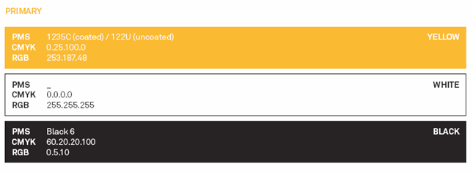

**Brand Application**

**5. Branding Examples**

This table outlines where the USU endorsement logo is required as well as the recommended positioning and use of other USU branding.

|  |  |  |
| --- | --- | --- |
| **Medium** | **USU Logo/linking Required** | **Recommended**  **Position** |
| Posters / flyers and other  printed material | USU endorsement logo | Bottom strip |
| Banners – pull up /  feather | USU endorsement logo | Top/bottom strip |
| T-Shirts | USU endorsement logo | Sleeve cuff  Front of shirt or  back - 10cm below  the nape |
| Newsletters printed | USU endorsement logo | Front page |
| Websites / eNewsletter | USU endorsement logo  Embed link to [www.usuonline.com](http://www.usuonline.com)  Access logo (where Access pricing is detailed) | Homepage / top of  eNewsletter |
| Facebook | Link to [www.usuonline.com](http://www.usuonline.com)  Like our page: facebook.com/USUAccess | Info tab |
| Twitter | Follow us: [twitter.com/USUAccess](http://twitter.com/USUAccess) |  |

**6. Artwork Approval**

**Print jobs cannot commence without the C&S Team’s approval of the artwork.**

Clubs and societies will not be funded for printing, advertisements or other promotional materials if:

The USU endorsement logo is displayed incorrectly

Printing has occurred without the C&S Team’s approval

Materials produced without the USU endorsement logo will be removed from circulation.

Email artwork for approval and ensure files are under 5MB. You can compress files to reduce the file size and create a low resolution PDF. If artwork is larger you can use an FTP transfer service like YouSendIt or Dropbox to upload artwork and forward us the link.

**7. Marketing Contacts**

For all branding and print enquiries please email Anjali Belani and Menuka Mudliar:

**Anjali Belani**

Design Manager

[a.belani@usu.usyd.edu.au](mailto:a.belani@usu.usyd.edu.au)

**Menuka Mudliar**

Sales & Marketing Assistant

[m.mudliar@usu.usyd.edu.au](mailto:m.mudliar@usu.usyd.edu.au)